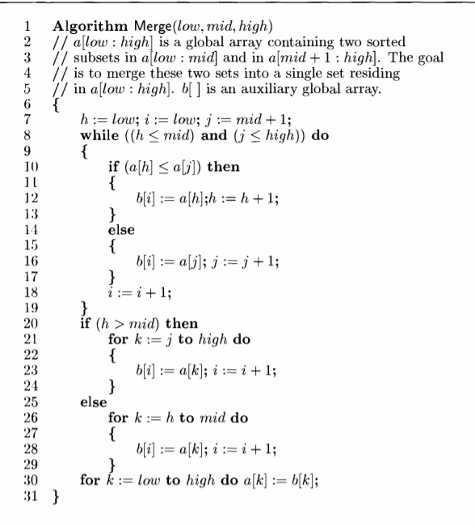

**Input:::**

Low---0

High—7

Mid---3

| 5 | 6 | 7 | 8 | 1 | 2 | 3 | 4 |
| --- | --- | --- | --- | --- | --- | --- | --- |
| 0 | 1 | 2 | 3 | 4 | 5 | 6 | 7 |

A(0---3)------sorted

A(4----7)------sorted

Merge(0,3,7)-------------is the call to the merge algorithm

I Iteration

A array

| 5 | 6 | | 7 | | 8 | | 1 | | 2 | | 3 | | 4 |
| --- | --- | --- | --- | --- | --- | --- | --- | --- | --- | --- | --- | --- | --- |
| 0 | 1 | | 2 | | 3 | | 4 | | 5 | | 6 | | 7 |
| Low | | Mid | | High | | H=low | | I==low | | J=mid+1 | |
| 0 | | 3 | | 7 | | 0 | | 0 | | 4 | |
| While (h<=mid) &&(j<=high)----0<=3 &&4<=7 | | | | | | | | | | | |
| If (a[h]<=a[j] ---a[0]<=a4]-----5<=1 | | | | | | | | | | | |
|  | |  | |  | |  | |  | |  | |
| Else part---b[i]=a[j];j=j+1 | | | | | | | | | | | |
|  | |  | |  | |  | | 1 | | 5 | |

B array

| 1 |  |  |  |  |  |  |  |
| --- | --- | --- | --- | --- | --- | --- | --- |
| 0 | 1 | 2 | 3 | 4 | 5 | 6 | 7 |

II Iteration

A array

| 5 | 6 | | 7 | | 8 | | 1 | | 2 | | 3 | | 4 |
| --- | --- | --- | --- | --- | --- | --- | --- | --- | --- | --- | --- | --- | --- |
| 0 | 1 | | 2 | | 3 | | 4 | | 5 | | 6 | | 7 |
| Low | | Mid | | High | | H=low | | I==low | | J=mid+1 | |
| 0 | | 3 | | 7 | | 0 | | 0 | | 4 | |
| While (h<=mid) &&(j<=high)----0<=3 && 5<=7 | | | | | | | | | | | |
| If (a[h]<=a[j] ---a[0]<=a5]-----5<=2 | | | | | | | | | | | |
|  | |  | |  | |  | |  | |  | |
| Else part---b[i]=a[j];j=j+1 | | | | | | | | | | | |
|  | |  | |  | |  | | 1 | | 5 | |
|  | |  | |  | |  | | 2 | | 6 | |

B array

| 1 | 2 |  |  |  |  |  |  |
| --- | --- | --- | --- | --- | --- | --- | --- |
| 0 | 1 | 2 | 3 | 4 | 5 | 6 | 7 |

III Iteration

A array

| 5 | 6 | | 7 | | 8 | | 1 | | 2 | | 3 | | 4 |
| --- | --- | --- | --- | --- | --- | --- | --- | --- | --- | --- | --- | --- | --- |
| 0 | 1 | | 2 | | 3 | | 4 | | 5 | | 6 | | 7 |
| Low | | Mid | | High | | H=low | | I==low | | J=mid+1 | |
| 0 | | 3 | | 7 | | 0 | | 0 | | 4 | |
| While (h<=mid) &&(j<=high)----0<=3 && 6<=7 | | | | | | | | | | | |
| If (a[h]<=a[j] ---a[0]<=a[6]-----5<=3 | | | | | | | | | | | |
|  | |  | |  | |  | |  | |  | |
| Else part---b[i]=a[j];j=j+1 | | | | | | | | | | | |
|  | |  | |  | |  | | 1 | | 5 | |
|  | |  | |  | |  | | 2 | | 6 | |
|  | |  | |  | |  | | 3 | | 7 | |

B array

| 1 | 2 | 3 |  |  |  |  |  |
| --- | --- | --- | --- | --- | --- | --- | --- |
| 0 | 1 | 2 | 3 | 4 | 5 | 6 | 7 |

IV Iteration

A array

| 5 | 6 | | 7 | | 8 | | 1 | | 2 | | 3 | | 4 |
| --- | --- | --- | --- | --- | --- | --- | --- | --- | --- | --- | --- | --- | --- |
| 0 | 1 | | 2 | | 3 | | 4 | | 5 | | 6 | | 7 |
| Low | | Mid | | High | | H=low | | I==low | | J=mid+1 | |
| 0 | | 3 | | 7 | | 0 | | 0 | | 4 | |
| While (h<=mid) &&(j<=high)----0<=3 && 7<=7 | | | | | | | | | | | |
| If (a[h]<=a[j] ---a[0]<=a[7]-----5<=4 | | | | | | | | | | | |
|  | |  | |  | |  | |  | |  | |
| Else part---b[i]=a[j];j=j+1 | | | | | | | | | | | |
|  | |  | |  | |  | | 1 | | 5 | |
|  | |  | |  | |  | | 2 | | 6 | |
|  | |  | |  | |  | | 3 | | 7 | |
|  | |  | |  | |  | | 4 | | 8 | |

B array

| 1 | 2 | 3 | 4 |  |  |  |  |
| --- | --- | --- | --- | --- | --- | --- | --- |
| 0 | 1 | 2 | 3 | 4 | 5 | 6 | 7 |

//copy the remaining elements

If h>mid-----0>3----------else part

For k=h to mid

B[i]=a[k];

I++

B[4]=a[o]

B[5]=a[1]

B[6]=a[2]

B[7]=a[3]

B array

| 1 | 2 | 3 | 4 | 5 | 6 | 7 | 8 |
| --- | --- | --- | --- | --- | --- | --- | --- |
| 0 | 1 | 2 | 3 | 4 | 5 | 6 | 7 |